Español 1 Nombre ______________________________________________

Capítulo 5 Fecha _________________________________________________

Casa Ideal

**La Casa de Mis Sueños** (The House of my Dreams)

Tú eres un arquitecto. Quieres construir tu casa ideal. No hay problema con dinero; eres rico. (Imagine that) you are an arquitect, and you want to build your ideal house. Money is not a problem; you are rich.

***\*The first part of your project is to create a “blueprint” for your house****.*

1. Your house must have **at least 7 rooms and 2 floors**. (Don’t forget the yard and garage!)
   1. Each room of the house must **be labeled in Spanish** (i.e. “el dormitorio”, “el baño”)
2. Each room must be “decorated” with furniture and objects that you would typically find in that room.
   1. **You should have at least 3-5 per room, labeled in Spanish!**

**\*Your decorations, furniture, and objects must be cut out from magazines, newspaper ads AND/OR printed images from the computer or hand drawn.**

***\*The second portion of your project requires some writing in Spanish****.*

Your paragraphs can be hand written *(please write on the provided paper)* or typed and will be graded using the Fairfax County writing rubric.

1. **Write 2 paragraphs in Spanish (a minimum of 10 sentences) describing your house in general**. You can describe the size of your house, the colors of the rooms, how many of each room, where each room is located (estar with prepostions), the address, who lives with you, where you live, chores that are done in each room, etc.
2. **Write 2 paragraphs (a minimum of 10 sentences) describing your favorite room of the house**. Be sure to mention why it is your favorite room, and you should include some of your favorite activities that you can do in that room.

***\*How should my final “blue print” look?***

That’s up to you as long as you fulfill all of the requirements! Some possible ideas are:

* A brochure of your ideal house
* A poster board presentation of your ideal house
* A section view of your ideal house or a floor view of your ideal house (see example below)

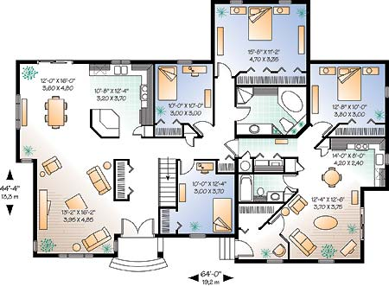

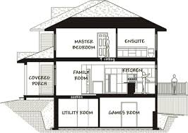

***La Casa de Mis Sueños…***

____________________________________________________________________________________________________________________________________________________________________________________________________________________________________________________________________________________________________________________________________________________________________________________________________________________________________________________________________________________________________

__________________________________________________________________________________________________________________________________________________________________________________________________________________________________________________

__________________________________________________________________________________________________________________________________________________________________________________________________________________________________________________

__________________________________________________________________________________________________________________________________________________________________________________________________________________________________________________

__________________________________________________________________________________________________________________________________________________________________________________________________________________________________________________

__________________________________________________________________________________________________________________________________________________________________________________________________________________________________________________

__________________________________________________________________________________________________________________________________________________________________________________________________________________________________________________

__________________________________________________________________________________________________________________________________________________________________________________________________________________________________________________

__________________________________________________________________________________________________________________________________________________________________________________________________________________________________________________

__________________________________________________________________________________________________________________________________________________________________________________________________________________________________________________

_________________________________________________________________________________________________________________________

**La Casa de Mis Sueños (cont.)…**

__________________________________________________________________________________________________________________________________________________________________________________________________________________________________________________

__________________________________________________________________________________________________________________________________________________________________________________________________________________________________________________

__________________________________________________________________________________________________________________________________________________________________________________________________________________________________________________

__________________________________________________________________________________________________________________________________________________________________________________________________________________________________________________

__________________________________________________________________________________________________________________________________________________________________________________________________________________________________________________

__________________________________________________________________________________________________________________________________________________________________________________________________________________________________________________

__________________________________________________________________________________________________________________________________________________________________________________________________________________________________________________

__________________________________________________________________________________________________________________________________________________________________________________________________________________________________________________

__________________________________________________________________________________________________________________________________________________________________________________________________________________________________________________

__________________________________________________________________________________________________________________________________________________________________________________________________________________________________________________

__________________________________________________________________________________________________________________________________________________________________________________________________________________________________________________

__________________________________________________________________________________________________________________________________________________________________________________________________________________________________________________