Español I Nombre-

Tarea Checklist: Chapter 2 Part 1 (Due October 7th)

Complete at least SIX activities total by the end of the first part of the chapter (October 7th). At least ONE must be from EACH column and then TWO more from the areas where you are struggling. Show Sra. Holick to get a stamp as you complete the activities and turn this paper in. You cannot get more than two stamps in a day. DO NOT wait until the last minute!!

Vocabulary  (September 28th) | Numbers, age, birthdays  (September 30th) | Noun/Adjective Agreement  (October 1st) | Question Words  (Ocotber 5th)
1. Complete pages 13 and 14 in the workbook | 1. Complete workbook page 15. | 1. Complete workbook pages 16 and 17. | 1. Complete workbook page 18.
2. Log on to the textbook website (go.hrw.com). Click on “go to the online textbook”. Go to page 44 and complete the “more practice” activity and either print your results or show Sra. Holick a screenshot. | 2. Make a set of flashcards for all of the 2.1 vocabulary | 2. Log on to the textbook website (go.hrw.com). Click on “go to the online textbook”. Go to page 48 and complete the “more practice” activity and either print your results or show Sra. Holick a screenshot. | 2. Visit Sra. Holick’s website http://www.sraholick.weebly.com, click on Exprésate, Capítulo 2. Click on the “Question Word Practice” link and complete the activity. Print your results or take a screenshot to show Sra. Holick.
3. Scan the QR code to the 2.1 vocabulary quizlet. Take the test and either email your results to Sra. Holick or take a screenshot.  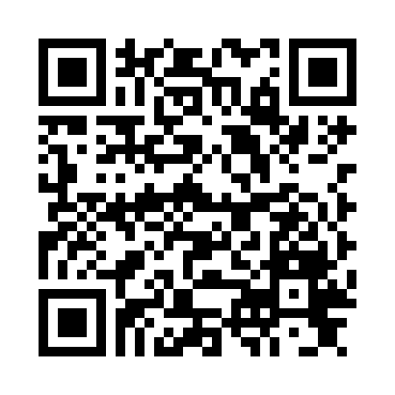 | 3. Log on to www.conjuguemos.com, click on the “Numbers 0-100” activity. When finished, check your work and either take a screenshot or print out your results to show Sra. Holick. | 3. Log on to www.conjuguemos.com, click on the “Noun Adjective Agreement” activity. When finished, check your work and either take a screenshot or print out your results to show Sra. Holick. | 3. Log on to www.conjuguemos.com, click on the “Question Words” activity. Set the timer for 10 minutes. Once you finish, click “Record/send results” and Sra. Holick will get an email with your results.
Everyone must also complete the following by Friday, October 1st: Download a free QR reader app onto your device.
Download the app “Recordings Lite” onto your device.

