Español I Nombre-

Tarea Checklist: Chapter 3 Part 2 (Due December 7th)

Complete at least SIX activities total by the end of the second part of the Chapter (December 7th). At least ONE must be from EACH column and then TWO more from the areas where you are struggling. Show Sra. Holick to get a stamp as you complete the activities and turn this paper in. You cannot get more than two stamps in a day. DO NOT wait until the last minute!!

Vocabulary  (November 16th) | -AR, -ER, and -IR verbs  (November 19th) | Irregular/Stem-Changers  (November 30th) | Weather  (December 3rd)
1. Complete pages 31 and 32 in your workbook | 1. Complete page 34 and 47 in your workbook. | 1. Complete workbook page 35 and activities # 29 & 30 on page 36 | 1. Complete activity #31 on page 36
2. Create a set of flashcards for the 3.2 vocabulary | 2. Log on to the textbook website (go.hrw.com). Click on “go to the online textbook”. Go to page 98 and complete the “more practice” activity. Either print your results or show Sra. Holick a screenshot. | 2. Log on to the textbook website (go.hrw.com). Click on “go to the online textbook”. Go to page 100 and complete the “more practice” activity. Either print your results or show Sra. Holick a screenshot. | 2. Complete the yellow worksheet clipped to the board.
3. Scan the QR code to reach the 3.2 Vocabulary Quizlet. Take the test and either print your results or show Sra. Holick a screenshot.  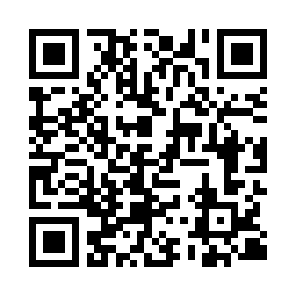 | 3. Scan the QR code to reach the Regular Verb Conjugations Quizlet. Take the test and either print your results or show Sra. Holick a screenshot.  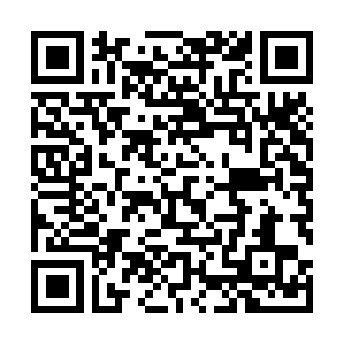 | 3. Log on to www.conjuguemos.com, click on the “Irregular and Stem Changer Verbs” activity. Set the timer for 10 minutes and complete the work. When finished, check your work and either take a screenshot or email your results to Sra. Holick. | 3. Log on to the textbook website (go.hrw.com). Click on “go to the online textbook”. Go to page 102 and complete the “more practice” activity. Either print your results or show Sra. Holick a screenshot.

