Español I Nombre-

Tarea Checklist: Chapters 7 & 8 (Due May 19th)

Complete at least SIX activities total by the end of the second part of the Chapter (May 19th). At least ONE must be from EACH column and then TWO more from the areas where you are struggling. Show Sra. Holick to get a stamp as you complete the activities and turn this paper in. You cannot get more than two stamps in a day. DO NOT wait until the last minute!!

Vocabulary  May 9th | Doler and Body Parts  May 12th | Reflexives  May 13th | Review  May 16th
1. Make a set of flashcards for the Chapters 7/8 Vocabulary | 1. Draw and label IN SPANISH 10 body parts and 5 articles of clothing on a drawing of a person or animal. | 1. Complete page 76 in the workbook. | 1. Create a review guide WITH ANSWER KEY for the information within Chapters 7/8
2. Complete the extra YELLOW worksheet. | 2. Go to the website join.quizizz.com and enter the code:  Play the quiz and either take a screenshot of your results or email me to tell me that you have completed the quiz. | 2. Log on to the textbook website (go.hrw.com). Click on “go to the online textbook”. Go to page 238 and complete the “more practice” activity and either print your results or show Sra. Holick a screenshot. | 2. Scan the QR code to reach the Reflexive Verb Conjugation Quizlet. Take the test and either print your results or show Sra. Holick a screenshot.
3. Scan the QR code to reach the 7/8 Vocabulary Quizlet. Take the test and either print your results or show Sra. Holick a screenshot | 3. Log on to conjuguemos.com, click on the activity “Body Parts and Doler” Show Sra. Holick your results.  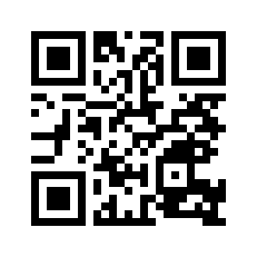 | 3. Log on to conjuguemos.com, click on the activity “Reflexive Verbs #1” Show Sra. Holick your results.  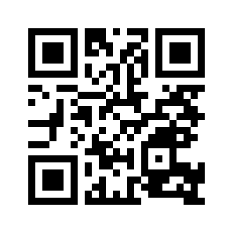 | 3. Go to the website join.quizizz.com and enter the code:  Play the quiz and either take a screenshot of your results or email me to tell me that you have completed the quiz.

