Español I Nombre-
Capítulo Seis
Gramática Fecha-

Mandatos
Regulares
Add the milk. ______________________________________
Cut the apple. ______________________________________
Drink the juice. ______________________________________
Heat up the meat. ______________________________________
Eat dinner with your family. ______________________________________
Mix the salad. ______________________________________
Based on the above sentences and the powerpoint come up with a few conclusions about how regular commands are formed below.

Irregulares: Write the infinitive verb you believe the command stems from.
- Ven a la escuela durante la semana.
- Ten cuidado.
- Pon la mesa.
- Sal con amigos los fines de semana.
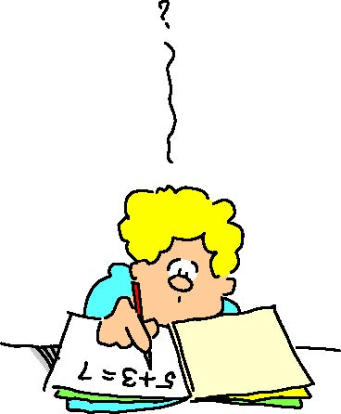
- Haz la tarea.
- Sé simpático.
- Di la verdad.
- Ve a la casa.

Informal Commands with Direct Object Pronouns:
Wash them. ____________________________________
Eat it. ____________________________________
Order/ask for it. ____________________________________
Cook them. ____________________________________
Prepare it. ____________________________________
Based on the commands with direct object pronouns above, write you conclusions about how to form them in the space provided below.

Práctica:
A. Complete the sentence with the correct informal command.
- _____________(Servir) la ensalada fría.
- _____________(Lavar) las frutas.
- _____________(Probar) la ensalada para ver qué tal está.
- _____________(Añadir) un poco de azúcar (sugar).
- _____________(Cortar) las frutas en trozos (pieces).
B. Your friend needs help moving. Tell her where to put the following things.
For example: el refrigerador: Ponlo en la cocina.
- La cama ______________________________________________________
- Las plantas ____________________________________________________
- La comida _____________________________________________________
- Los vasos _____________________________________________________
C. Answer the following questions using an informal command and a direct object pronoun.
- ¿Caliento la sopa antes de preparar el pollo o después? _____________________________________________________________
- ¿Pongo las servilletas al lado de los platos o encima de ellos? _____________________________________________________________
- ¿Saco el flan del refrigerador antes de comer o después? ____________________________________________________________

