Español I Nombre-
Capítulo Seis
Cultura Fecha-

México
Usa las páginas 190-193 en tu libro para responder a las siguientes preguntas.

1. What is México’s capital?
2. Where is the volcano Popocatépetl located?
3. What is El Jarabe tapatio characterized for?
4. In what state is Agua Azul located?
5. What does the name Agua Azul mean?
6. Who painted Vendedora de Alcatraces?
7. What is one thing you notice about the city of Taxco?
8. What was Diego Rivera married to? (hint: he lived with her)
9. What is in mole poblano?
10. When is Mexico’s Independence Day?

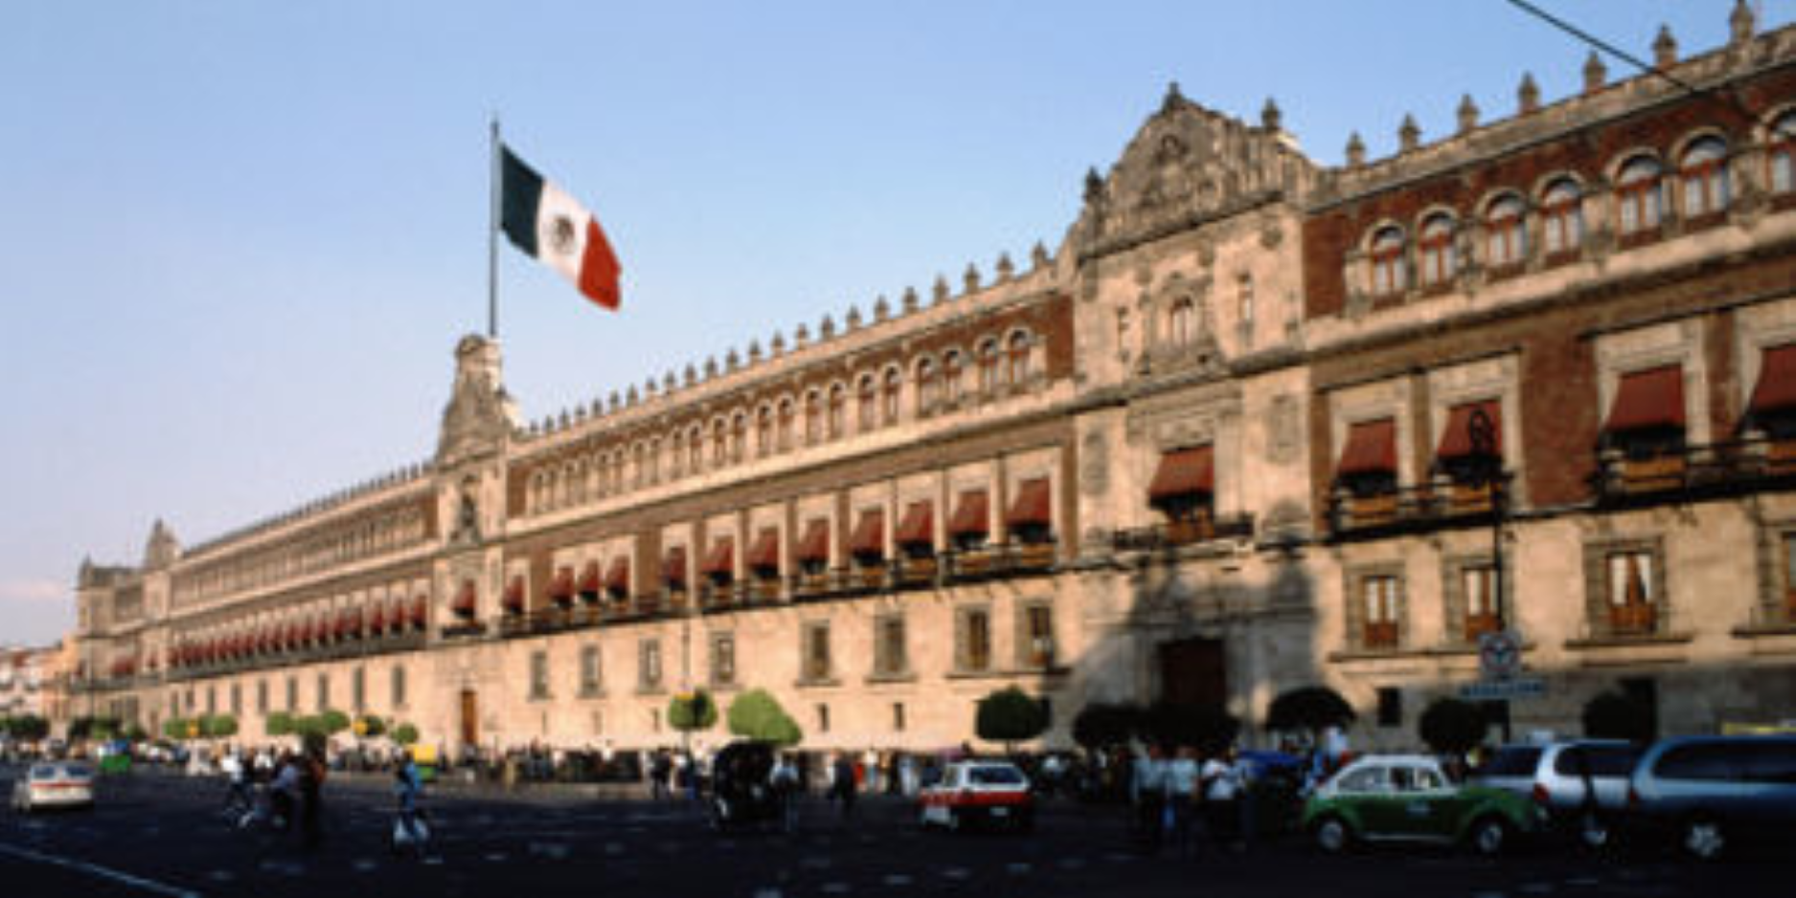
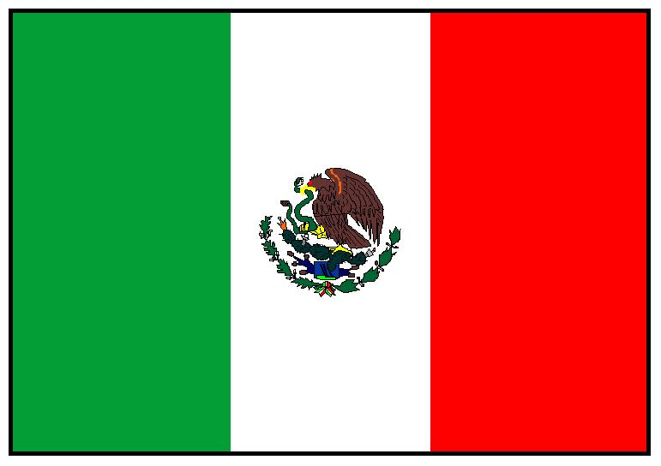

Otra Información de México
1. What is the name of the town where Sra. Combs studied abroad?

2. What’s the word for the center of town?

3. What can you find in the zócalo?

4. What city is known for its silver production?

5. What two interesting things can be found in Tepoztlán?

6. What are the two pyramids located at Teotihuacán?

7. Who built the city of Tulum?

8. Where is La Catedral Metropolitana de la Asunción de María located?

9. What is special about it?

10. What is in the Palacio Nacional?

