Español I Nombre-
Capítulo Dos
Cultura Fecha-
Puerto Rico

1. What is the capital of Puerto Rico?

2. What type of government does Puerto Rico have?

3. What are the official languages of Puerto Rico?

4. What type of currency is used in Puerto Rico?

5. What is the coquí and what is it names for?

6. What is El Yunque?

7. What is El Morro?

8. What common food in Puerto Rico is often eaten with rice?

9. What are tostones?

10. What sport is popular in Puerto Rico?

11. What does Taino art show?

12. What is used to make vejigante masks?

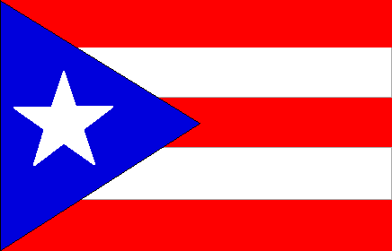
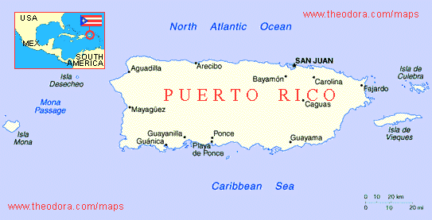
13. Who claimed Puerto Rico for Spain in 1493?

