Español I Nombre-
Capítulo Tres
Cultura Fecha-

Texas

Answer the following questions based on pages 76-79 in your book.
1. What country and states border Texas?

2. What is the official state fruit of Texas?

3. Where does the name Big Bend National Park come from?

4. What multicultural city is famous for its Paseo del Río?

5. What port handles the largest amount of international sea trade in the United States?

6. What governments has Texas been ruled by?

7. What is the official state snack of Texas?

8. Where is the fiberglass sculpture Vaquero found?

9. What does the cinco de mayo commemorate?

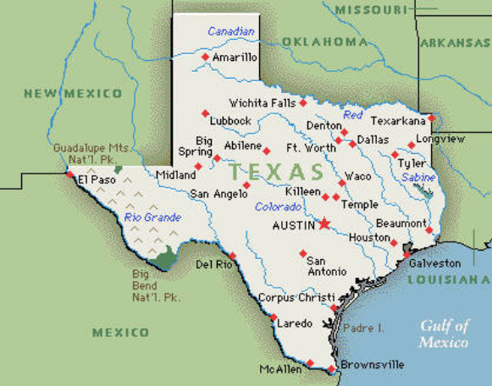
10. In your opinion, where do you see the biggest Mexican influence on Texas?
Se Habla Español

English is the official language of Texas, but nearly 3 out of 10 Texans claim to be of Hispanic origin.

